Statistics with R programming

Thanuja R

11.

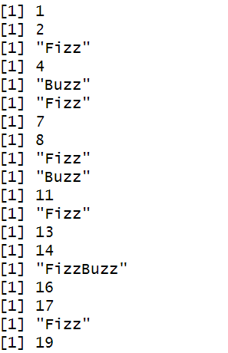

14.



13.

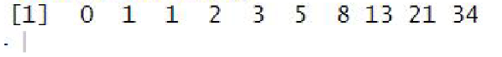

12



15.

16

